Seed Sowing Workshop

Logistics
Date: Saturday, Jan 31 or Feb 7
Time: ~9:00-12:00p
Place: ACES Extension Office (Charles Stone Agricultural Center: 819 Cook Avenue, Huntsville, AL 35801)
Attendees: Ideally 20, max 30
Fee: Free for Members, maybe $15 for non-members? Or members only is fine

Volunteers
Sara Johnson - North American Land Trust / HEC - Facilitator / Leader
Sara Cline - possible co-facilitator or panel member
Denise Woodring - possible co-facilitator or panel member (maybe able to supply seeds for giveaway / demo)
Charles Pannell - WONA Representative / co-facilitator

Content

Loose schedule:
9:00 - 9:30: Intro to self, panelists, WONA
9:30 - 10:30: Lecture / Skills Training
10:30 - 10:45: Snacks / Bathroom Break
10:45 - 11:30: Lecture / Skills Training
11:30 - 12:00: Q & A and Wrap-up

Hybrid lecture and skills demonstration/training to include:
- Types of seeds and what you can learn about them based on traits
  - Show and tell of various seeds
    - Planting depth, Seed coats, Dispersal etc.
- Seed cleaning and how to prepare various types of seed/fruit
  - Conventional vs. unconventional seed
- Seed Storage
  - Temperature, Humidity, Decay / Fungal issues, Time / Age
- How to know when ready for harvest
- Basic collection ethics, particularly with sensitive/rare species
  - Permissions to collect, 10% rule for rare species
- Where to source native seed and how to know what to buy
- Seed stratification/scarification (physical and temperature)
  - Dormancy / Double dormancy
- Types of Soil / Substrate
- Sowing Method
  - Milk-jug method (demo and group activity), Tray method (demo), Pots (demo)
  - Direct Sow (how to know when area is ready to be seeded / soil conditions and temp / planting depth etc)
- Other helpful supplies
  - Dibble, Labels, Fencing and chicken wire (e.g. how to protect from critters)
- Resources (printout and in-person show and tell)
  - Books, Web resources, BBHF Habitat Management Guide, CPC Rare Plant Academy: Seed Propagation

Budget
Seeds: Sara is crowdsourcing lots of seeds!
Seed Envelopes: 50 pk - $10?
1 bag of Soil: $30
5 or so spray bottles: $5-10
2 or 3 rolls of duct tape: $5-10
Snacks: Purchase some snacks / drinks or have a couple homemade items

Total Cost: ~$100

Group-Activity Materials (Jug-Method for Winter Sowing)

● Spray bottles (see budget above)
● Potting soil (see budget above)
● Labels (Sara to provide)
● Scoopers or cups for soil (Sara to provide)
● Native seeds (Sara to provide)
● Books/printed references (Sara to provide)
● Scissors (Sara to provide)
● Box cutters (Sara to provide)
● Duck/duct tape (see budget above)
● Clean gallon jugs (4–5 per person) - can we crowd source?
● Pre-planted demo jug (Sara to provide)
● Apron (optional) (attendee provided if desired)
● Tablecloths (Sara to provide)

Example Flyer

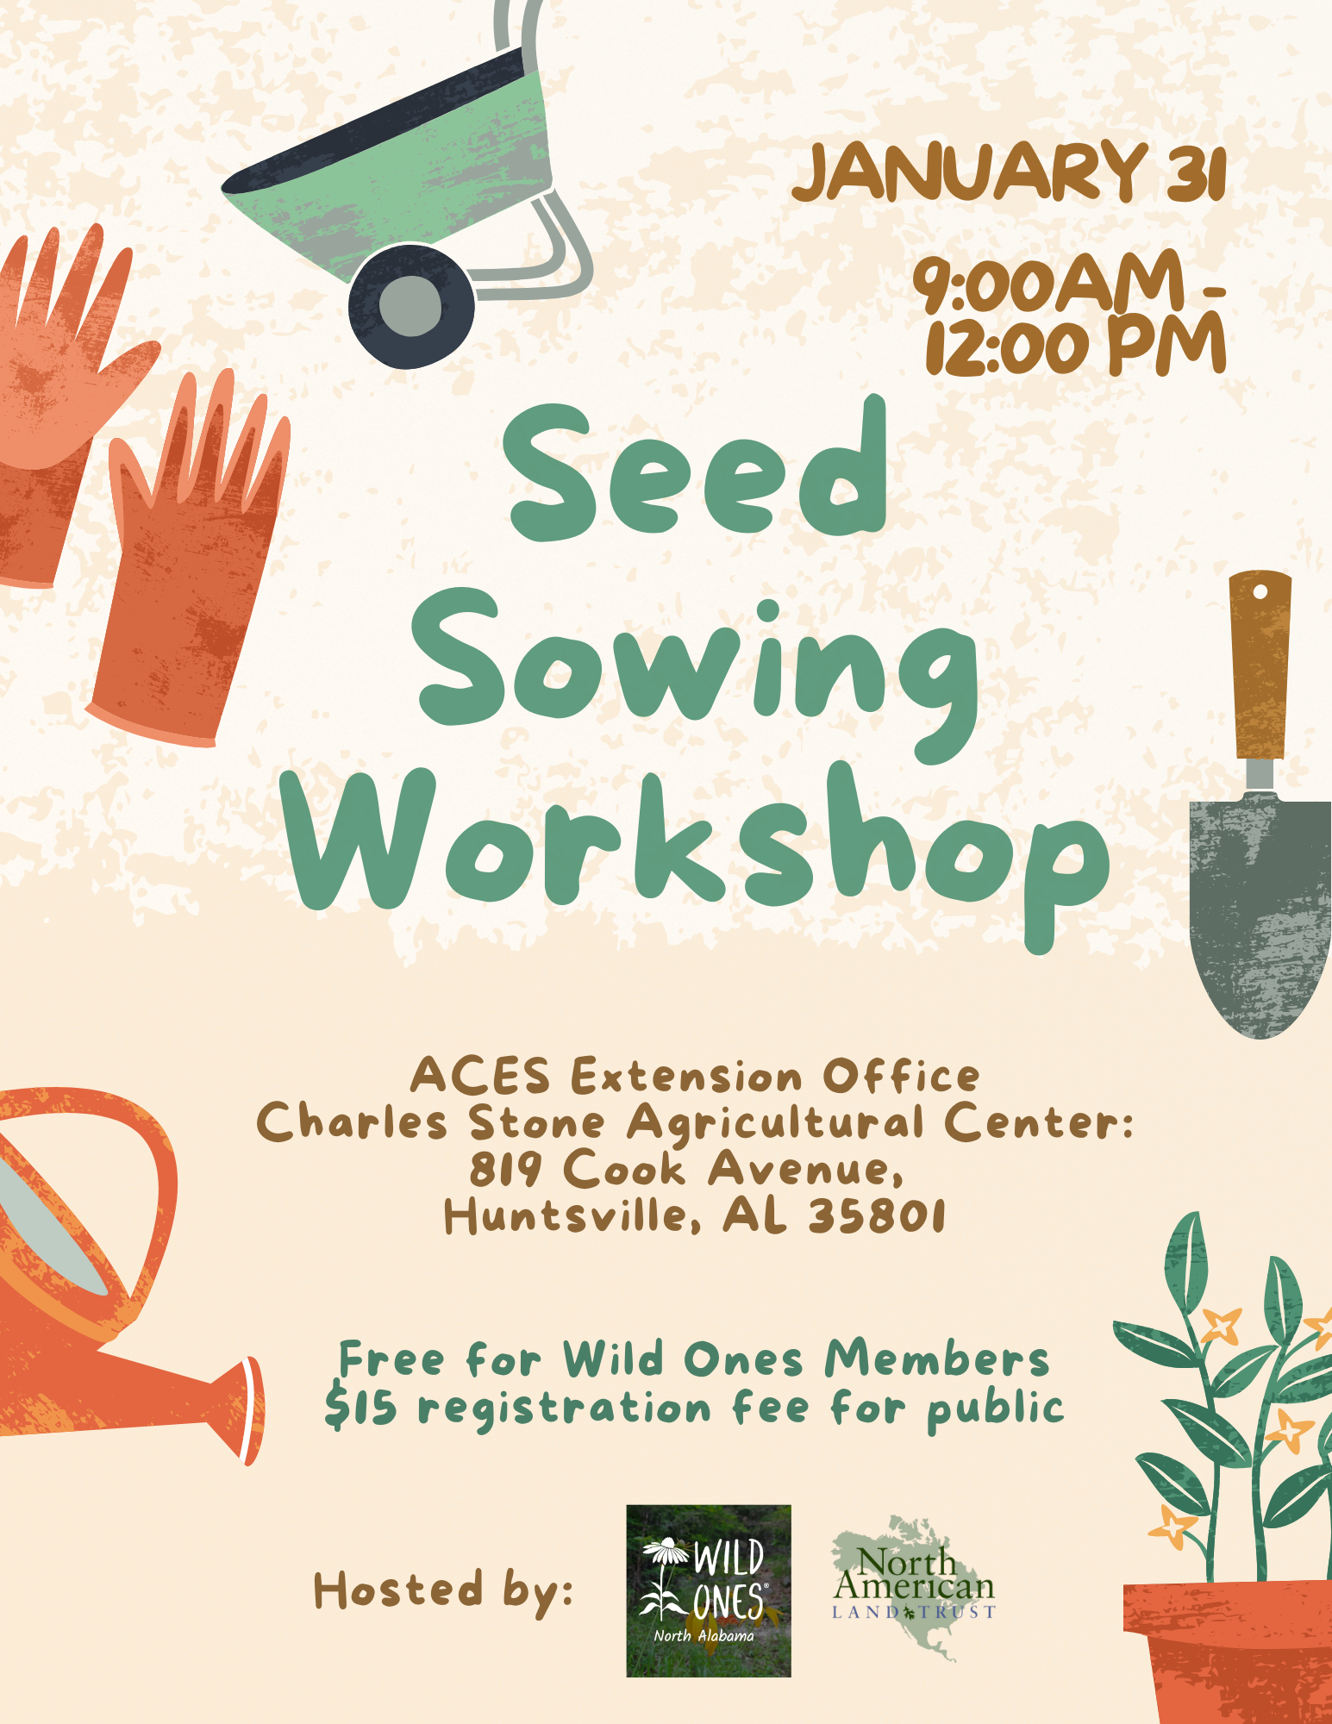
Winter Sowing is a propagation method used by many in temperate regions in late winter to get an early start on seeding for both native and early season perennials and edible plants.

The reason you may want to winter sow:
- It is low cost
  - Great if you lack supplies or indoor space
  - Growing your plants from seed allows you to grow a greater variety of plants at a huge cost benefit
- simple to do
  - Also fun, because it's cold and I want to garden!
- low effort to maintain
  - Contained conditions allow a microclimate for temperature and moisture.

It also is beneficial to plants for many reasons that we will talk about later.
- Can increase germination success and percentage by maintaining a stable growing environment.
- Plants that are winter-sown are pre-hardened off by growing in the elements, so they are immediately hardier and more adapted to your climate conditions. Ready to be planted out as soon as they reach the right size (2 sets of true leaves / ~3 inc)
- Provides Natural Stratification
- Planting in cover protects plants from harsh weather, being washed away, etc, including herbivores and pests
- No need to scarify or pre-soak when winter sowing because the natural freeze-thaw helps to do that work for you and break down the seed coat.

Container requirements
- Should be deep enough for at least 3 or more inches of soil
- Drainage holes
- Venting holes on top (keep caps off)
- At least 2-3 inches of headroom for seedlings to grow
- Clear top or lid for sunlight
What have I typically used?
- Salad containers, milk jugs, water jugs, soda / juice bottles, plastic totes/shoebox containers, etc. Can also use regular pots with some sort of cover or cold frame. (show photos or examples)

Potting Soil for Seeds
- High quality “Potting soil” or “soil-less” option - should not have lots of wood products etc -pre-moisten soil before adding seeds, tend to be static-y
- Don't use anything with a lack of nutrients like coir or seed starting mix unless you have mixed well with a compost or duff mix with nutrients.
- Don’t use anything with moisture retention or indoor potting mixes
- Fertilizer is tricky, you dont want too much when the seedlings are small, but as they begin to grow, they should be potted up into something with a light fertilizer (like black gold natural and organic)
Placement
- Directly outside where they will get sun and moisture. Snow is ok and will provide moisture and insulation.
- Put in a place where they will not be impacted by wind, support each other or put inside larger crates or totes / raised beds etc

Planting
- The more you plant, the more you need to thin / discard.
- Use instructions on packet or on web
- When to sow: I usually wait until early to mid-January. If you plant earlier and we get a warm spell, your seeds may pre-maturely sprout and be impacted by frost. Again, depends on whether you sow them under cover or out in the elements.
  - Most perennials need 4-6weeks of cold stratification

Maintenance
- Check on germination (expect certain seeds to take longer than others, especially warm season plants may take longer to germinate)
- Check daily to see how quickly water evaporates
- May need to add water during dry periods.
- Water gently, mist or trickle is ideal, so that you don’t disturb seed
- If no moisture obvious or visible in jug/container
- When have two true leaves (not cotyledons) can begin to up pot

